S



**Trade Risk Analysis System (TRAS) for**

**Global Investment Bank (GIB)**

**27th Jan 2022**

**SMILES. MINDFUL. INTEGRITY. LEARNING. EXCELLENCE. SOCIAL RESPONSIBILITY.**

Table of Contents

1. Vision Statement 5

2. Stakeholder Map 6

3. Point-Of-View (Business Goals) 7

4. Constraints 8

5. Architecture Design 10

6. Glossaries 13

|  |  |
| --- | --- |
| **Title** | Trade Risk Analysis System (TRAS) |
| **File Name** | Risk System for Global Investment Bank v0.1.docx |
| **Author** | Jignesh Chovatia  Nagaraja Yellarthy  Praveen Desu  Shashank Singh  Dileep Kadhati  Mohammed Khaleelulla |
| **Create Date** | 27/01/2022 |
| **Last Modified** | 27/01/2022 |
| **Version** | V1.0 |
| **Classification** | Internal |
| **Last review Date** | 27/01/2022 |
| **Next Review Date** | 27/02/2022 |

|  |  |  |  |  |
| --- | --- | --- | --- | --- |
| **Document History** | | | | |
| **Vision Number** | **Date** | **Prepared by / Modified by** | **Contributed** | **Significant Changes** |
| 0.1 | 27/01/2022 | Jignesh Chovatia  Nagaraja Yellarthy  Praveen Desu |  |  |
| 0.2 | 03/02/2022 | Jignesh Chovatia  Nagaraja Yellarthy  Praveen Desu  Dileep |  | Updated the Vision Statement |
| 0.3 | 04/02/2022 | Jignesh Chovatia  Nagaraja Yellarthy  Praveen Desu  Dileep  Sumanth |  | Point-Of-View (Business Goals)  Constrains |
| 0.4 | 10/02/2022 | Jignesh Chovatia  Nagaraja Yellarthy  Praveen Desu  Dileep |  | Architectural View  Monolithically Architecture  Micro Service Architecture |

# Vision Statement

For Global Investment Bank (GIB)

WHO needs to gain a view of how much risk of losing money exposed using the “Trade Risk Analysis System (TRAS)”

THE TRAS is a financial Risk prediction system

THAT uses the existing Trade Data System (TDS) and Reference Data System (RDS) to derive the profit or loses based on the stock markets move up or down and generate the Risk report

UNLIKE other financial risk calculation systems

OUR PRODUCT allows a subset of the authorized users to configure / modify the parameters used in the risk calculations, Risk reports will be available to users 24x7, reports will be allowed to accessible by the Business users within the confines of the bank’s global network. The system is capable of auto recovery based on the error logs, audit provision and external monitoring.

# Stakeholder Map

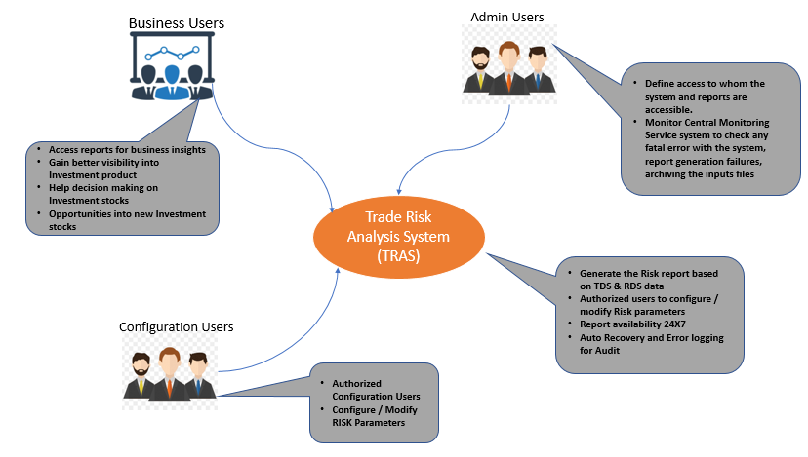

# Point-Of-View (Business Goals)

* Risk assessment reports gives the view of risk on the stock investments
* Reports should be available before 9 am of the next trading day so that will be handy for trading.
* Allows the user to configure (add / modify) the Risk Parameter for Risk calculations
* Sends the event (system, report generation failures, archiving the inputs files ) to Central Monitoring Service system for log audit as well as auto recovery.

# Constraints

**Business Constraints**

|  |  |  |  |
| --- | --- | --- | --- |
| **Constraint** | **Origin** | **Type** | **Context** |
| Report should be accessible through only bank network | Business Users | Business | To adhere to the Bank policy |
| System must adhere to the bank policy for access restricted to authenticated and authorized users only | Business Users | Business | To adhere to the Bank policy |

**Technical Constraints:**

|  |  |  |  |
| --- | --- | --- | --- |
| **Constraint** | **Origin** | **Type** | **Context** |
| Generate report that can be imported into Microsoft Excel engine containing the risk figure |  |  |  |
| Time Zone for exporting and consuming the files across geo locations |  |  |  |

​

**Quality Attributes:**

|  |  |  |
| --- | --- | --- |
| **Quality Attribute** | **Scenario** | **Priority** |
| Availability | Risk reports should be available to users 24x7, but a small amount of downtime (less than 30 minutes per day) can be tolerated | High |
| Security | system must follow bank policy that states system access is restricted to authenticated and authorized users only All access to the system and reports will be within the confines of the bank’s global network | High |
| Traceability | events to be recorded in the system audit logs i.   Report generation  ii.   Modification of risk calculation parameters | High |
| Archive | Input files used in the risk calculation process must be retained for 1 year | Medium |
| Localization | All User Interfaces and Risk reports will be presented in English | Medium |
|  |  |  |

**Architectural Influential Functional Requirements:**

* The system must be able to cope with trade volumes for the next 5 years
* Interfaces with existing data systems should conform to and use existing data formats.

# Architecture Design

1. Architecture Context Diagram

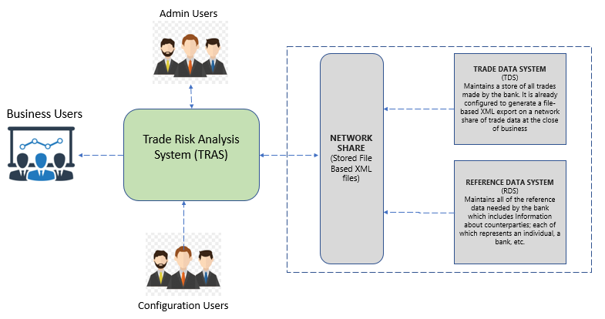

1. Architectural View

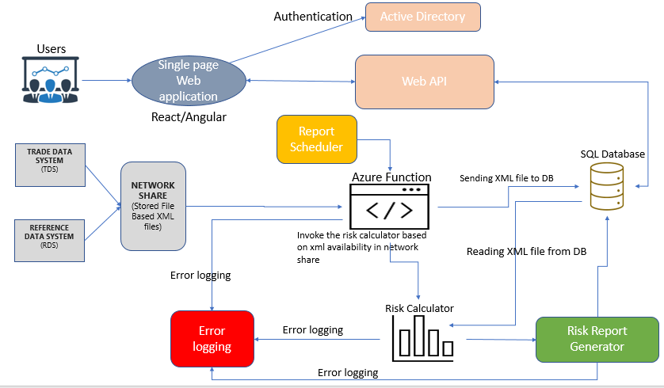

1. Monolithic Architecture

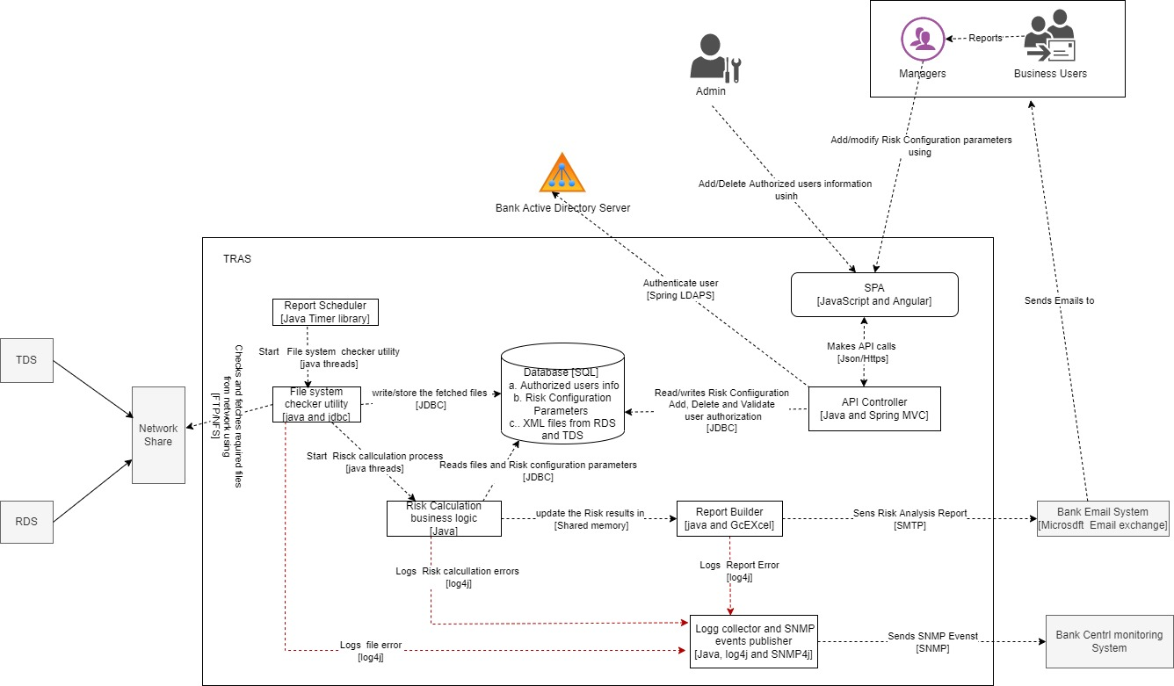

1. Micro Service Architecture

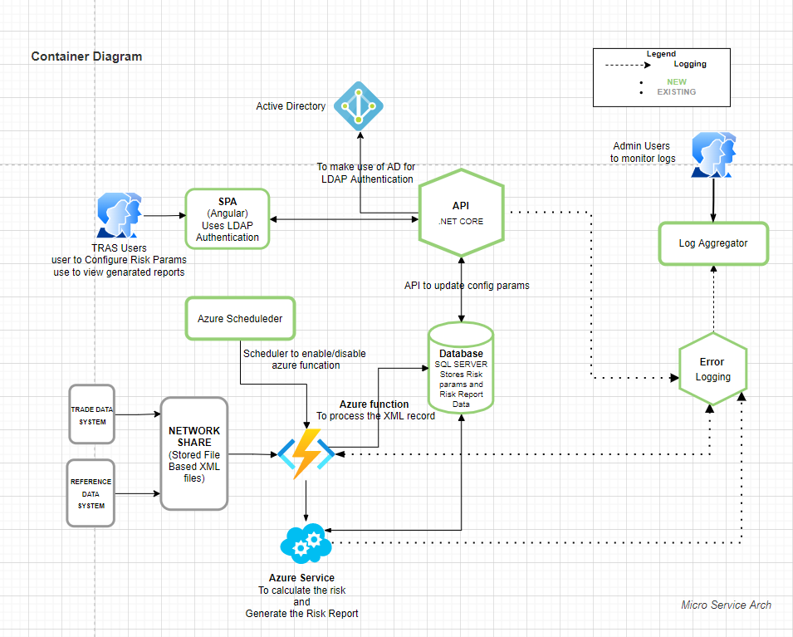

# Glossaries

Trade Data System (TDS) and Reference Data System (RDS)



**About Happiest Minds**

Happiest Minds Technologies is a next generation IT services company combining unparalleled experience, comprehensive capabilities across all industries and business roles, and forward-thinking advisory capabilities for the world’s top businesses, governments and organizations. Happiest Minds collaborates with customers to help them differentiate and win with a unique blend of solutions and services based on the core technology pillars of cloud computing, social computing, mobility and analytics. Founded in 2011, Happiest Minds is privately held with headquarters in Bangalore, India and offices in the USA and UK. For more information, visit:

[www.happiestminds.com](http://www.happiestminds.com)

**Corporate Office**

Happiest Minds Technologies Pvt Ltd

Smiles 1, 3rd & 4th Floor, SJR Equinox, Sy.No.47/8, Doddathogur Village, Begur Hobli, Electronics City,Phase 1, Hosur Road, Bengaluru – 560 100

Phone: +91 80 332 03333 | Fax: +91 80 332 03000

**Email:** contactus@happiestminds.com

www.happiestminds.com

United States

50 Division St, #501

Somerville, NJ 08876,  
Phone: +1-647-965-5276

United Kingdom

200 Brook Drive, Green Park, Reading  
Berkshire, RG2 6UB  
**Phone:** +44 118 925 6072 | **Fax:** + 44 118 925 6073